NEWSLETTER | June 2014
Disability Federation of Ireland
An advocate for the voluntary disability sector
Supporting organisations to enable people with disabilities

Budget 2015 Must Protect and Invest in People with Disabilities

The future of this country is very much bound up with whether we’re going to be an open, inclusive and participatory society, and this future must include people with disabilities. Although economic recovery is beginning to take hold, this group continues to be left behind. Since the onset of the recession, the cumulative impact of cutbacks has acutely damaged the services and supports that people with disabilities need to live ordinary lives in their own communities. Seven years of austerity is a long time for those who were already struggling at their commencement.
Budget 2015, taking place on 14th October, must protect and invest in people with disabilities and their families. This budget, unlike those which have gone before it, cannot be driven by financial considerations alone, but by the pursuit of sustainable social outcomes. There is a growing level of need which has unjustly been ignored: the downturn can no longer be used as a reason for depriving people with disabilities their basic rights as citizens. Further cuts to vital services and much-needed income supports for people with disabilities will not be acceptable. Confidence in economic recovery must also translate into confidence in knowing that people have a strong fabric of social supports behind them.
DFI is in the process of developing its Pre-Budget Submission, and we will be using it to make the case for an inclusive society that leaves nobody behind. Our work over the past year – including our Mid-Term Review of the Programme for Government, our ‘Access to Life’ report on Personal Assistant services and our Elections 2014 manifestos – has clearly highlighted the difficulties and challenges facing people with disabilities and their families. Government must use this Budget to demonstrate their commitment to this group by protecting the services and supports which enable them to live with the security and independence they are entitled to.

John Dolan, Chief Executive Officer

DFI Raises Concerns Over Austerity Measures at its Annual General Meeting
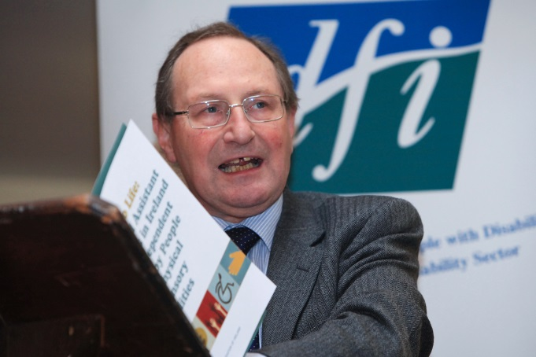
The Disability Federation of Ireland (DFI) was joined by numerous representatives of its member organisations and National Council for its Annual General Meeting (AGM), held on 28 May 2014 in Dublin Institute of Technology (DIT) Kevin Street.
As well as providing an overview of the organisation’s work over the last year, the event also saw the passing of five resolutions which allowed for changes to the company’s Memorandum and Articles of Association. These included adjustments relating to the rights and property of the company, its internal working rules and its registered name.
Maurice O’Connell, seen above, is retiring from his position as Chairperson of DFI.
In opening the meeting, Chair of DFI, Maurice O’Connell, discussed how the last year has been a challenging year for the organisation – and the community and voluntary (C&V) sector as a whole – in coping with the experience of austerity. Chief Executive, John Dolan, agreed, adding that DFI is gravely concerned about the chances that the National Disability Strategy (NDS) is actually going to give product and resources. He explained that 60 of the 92 actions have completion dates outside of the three year plan, which is worrying from the point of view of governance.
In this regard, the Mid-term Review of the Programme of Government on disability issues and the NDS, conducted by DFI in late 2013, was praised for highlighting some of the real concerns for people with disabilities and their families. DFI’s research, including the publication of the ‘Access to Life’ report on Personal Assistant (PA), and work on the international scene, such as its hosting of the “Getting Our European Act Together!” seminar in January, was also noted as being of increasing significance.
Image by Salvatore Vuono, courtesy of freedigitalphotos.net

Mr Dolan also used the opportunity to commend DFI staff for all they have achieved over the past year, and, on behalf of the organisation as a whole, thanked Maurice O’Connell, who is retiring as Chair of DFI, for his support and guidance.
DFI Seminar Addresses Regulation and Outcomes for People with Disabilities
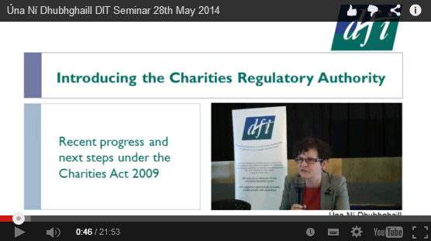
The recently-appointed Chief Executive of the Charities Regulatory Authority, Úna Ní Dhubhghaill, and the Deputy Director of Regulation at the Health Information and Quality Authority (HIQA), Niall Byrne, both addressed a seminar held by the Disability Federation of Ireland (DFI) on 28th May 2014.
The presentations given at the DFI seminar on regulation are available on the DFI website and on Youtube.
The event, ‘Regulation and Keeping the Focus on Best Outcomes for People with Disabilities’, explored the delivery and governance of person-centred supports and services for people with disabilities, examining the challenges that can arise and what this could mean for organisations.
Ms Ní Dhubhghaill provided an update on the implementation of the Charities Act, as well as the role and objectives of the new Charities Regulatory Authority. She explained that, under the Charities Act 2009, “there will be certain requirements that charities need to meet… obligations in relation to governance, obligations in relation to keeping proper accounts and to publishing certain information”. As part of this, charities will have to submit an annual report to the Charities Regulatory Authority, according to a template yet to be developed, and these reports will be made available to the public.
Meanwhile, Mr Byrne discussed the process and learnings of the HIQA National Quality Standards: Residential Services for People with Disabilities. He explained that HIQA want evidence from services that they are committed to and can deliver strong outcomes for people with disabilities: “residential services can and should be enabling of each person using them”. 225 inspections of residential centres have been conducted by HIQA to date – equivalent to 24% of the 953 registered centres – with 58 of these unannounced.
Followed by a Questions and Answers session, the event reflected on how an increased focus on regulation, coupled with an emphasis on health and safety, for example, could hinder the rights of people with disabilities to live independently and to exercise choice and control in their own lives, as established in Article 19 of the United Nations Convention on the Rights of Persons with Disabilities (UNCRPD).
The presentations given by Ms Ní Dhubhghaill and Mr Byrne, as well as the opening remarks given by DFI Chief Executive John Dolan, can be viewed at http://disability-federation.ie/index.php?uniqueID=10888

DFI Calls for Inclusion of People with Disabilities in Elections 2014 Campaign
Elections 2014 represented an important opportunity to have the voice of people with disabilities heard and listened to in the processes that affect their everyday lives. Here at the Disability Federation of Ireland (DFI), our ‘Ask Three Questions’ campaign worked to ensure that disability is placed firmly on the agenda. Here, we provide an overview of the campaign, and all the different elements it involved.
Local and European Elections 2014 Manifestos
On 12 May, DFI launched its Local Election 2014 and European Parliament Election 2014 manifestos at an event held outside Leinster House. The manifestos call on candidates to commit to working towards an equal society, fully inclusive to people with disabilities.

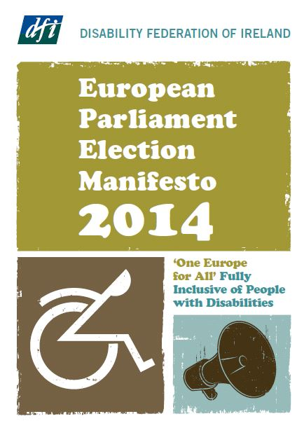
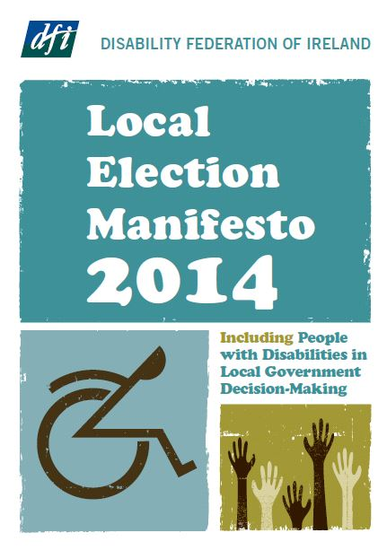

Our Local Election 2014 Manifesto urged candidates to commit to:
- Enable people with disabilities to access mainstream public services and supports;
- Promote and facilitate the participation of people with disabilities in local decision-making structures; and
- Guide local government by the National Disability Strategy Implementation Plan (NDSIP) and the United Nations Convention on the Rights of Persons with Disabilities (UNCRPD).
Our European Parliament Election 2014 Manifesto called on candidates to:
- Establish a Directorate for Disability Inclusion and appoint a Commissioner Vice President with dedicate responsibility for disability;
- Fully ratify and monitor the UNCRPD across Europe and in Ireland;
- Protect people with disabilities against the negative impact of austerity measures;
- Mainstream disability rights across all areas of the European Union and national policies;
- Establish ‘One Europe for All’ that is fully inclusive of people with disabilities; and
- Renew the commitment to a barrier-free Europe.
Speaking at their launch, Chief Executive of DFI, John Dolan, stated, “Today is not really about these elections; it is about the future of people with disabilities and their families. Since 2008, there have been consistent and growing cuts to necessary services and income supports that people with disabilities and their families rely on. These people have been left behind.”
He continued, “It has become clear that our public and social services have failed to protect the life chances of people with disabilities. There no longer exists a functional infrastructure of social supports in this state that is available when people with disabilities and their families need it. Only a committed, ambitious and determined state can deliver that and it needs the active support of the community to back it. Are we content to deliberately leave people and families behind?”
‘Leave Nobody Behind’ Pledge
DFI also called on all party leaders and candidates to the Local and European elections to sign its pledge to ‘Leave Nobody Behind’.
In total, eight of the 16 European candidates and 72 of the 130 Local candidates who signed the pledge were successfully elected following the nationwide vote on 23 May. Three party leaders – Mícheál Martin of Fianna Fáil, Eamon Ryan of the Green Party, and Gerry Adams of Sinn Féin – also endorsed the pledge.
The pledge represents a commitment to ensuring that people with disabilities do not get left behind in the social and economic recovery of the country, and to undertaking the implementation of DFI’s Top Election Priorities, as set out in our election manifestos.
Candidates promised to “work consistently to ensure that Ireland, as a matter of urgency, has a credible and functioning infrastructure of services and supports available to people with disabilities as a necessary part of Ireland’s recovery programme”.
On its part, the organisation committed to providing ongoing support to all elected candidates, and is now in the process of contacting all those elected to continue working towards the real inclusion and equality of people with disabilities in Ireland and Europe.
Ask Three Questions | Doorstep Questions Card
The ‘Doorsteps Question’ card was designed so that everyone had the important questions to hand whenever their local candidates came knocking to the door. People with disabilities count, and this card gave people with disabilities, their families, friends and communities the opportunity to raise the issues most important to them with those who now represent them.
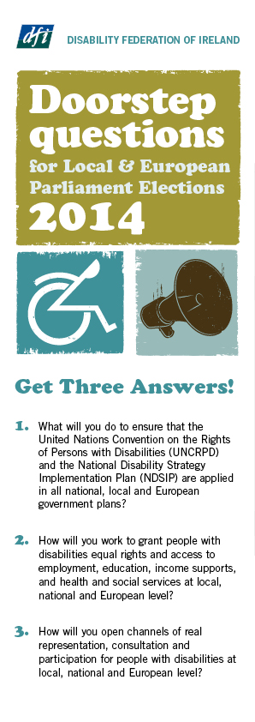
In Ireland, people with disabilities continue to endure significantly poorer social and economic outcomes. Disabled people remain twice as likely to live below the poverty line as the rest of the population, with 11% experiencing high levels of consistent poverty. Only 20% of people with disabilities are at work, compared to 50% for the overall population, while 43% have not progressed beyond primary education. These realities cannot be ignored any longer, and the issues addressed in this card aimed to push candidates at both local and European level to learn and do more about them.
Discussing the card, John Dolan explained, “We’re here to make a case for an inclusive society that says we leave nobody behind. Disability is a universal and societal issue; it is only when we truly listen to the voice of people with disabilities that we can move towards a fully inclusive and equal society.”
Youtube Videos
The DFI Elections 2014 campaign also saw the release of four videos with its Chief Executive, John Dolan, examining the importance and opportunities of the elections and the legacies left by disability campaigning.
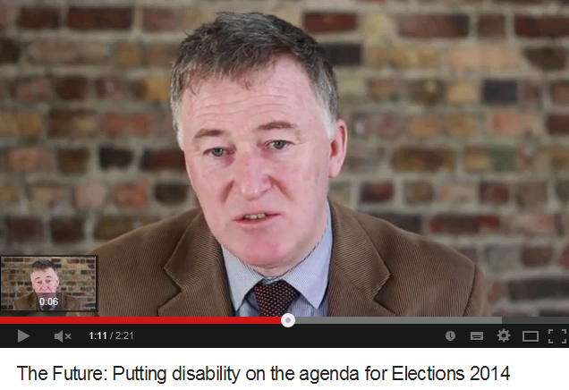

- In ‘Why Vote’, John stresses that disability is an issue for all of society, encouraging everyone to use their vote because “you do not leave any other human being behind”.
→ Watch it at https://www.youtube.com/watch?v=SwfLPW0VT6E

- “Legacy” looks at how the disability movement has fought for various rights and initiatives, such as universal design and accessibility, which have ultimately improved society as a whole: “these are all legacies left because of disability campaigning, but they are legacies left for everybody”.
→ Watch it at https://www.youtube.com/watch?v=rvyc3A3gAPs

- In “The Future”, John contends that politicians must work to make this “an inclusive, open and participative society” for everyone, just as people with disabilities must commit to engaging in and improving their communities.
→ Watch it at https://www.youtube.com/watch?v=PkaTn7AlR40
- Finally, “The EU Landscape” highlights the importance of having confidence that people have “a fabric of social supports” behind them, as well as confidence in economic recovery: “that’s what you need to power society and to power the economy”.
→ Watch it at https://www.youtube.com/watch?v=Rbdq2CO-bW8
Visit our Elections 2014 Hub for more information on all aspects of the DFI campaign: http://disability-federation.ie/index.php?uniqueID=10807. Visit and subscribe to our Youtube channel at https://www.youtube.comannel/UCsC9TjfreJSAGvdr7hkA1SA https://www.youtube.com/channel/UCsC9TjfreJSAGvdr7hkA1SA.

DFI Set to Host New Course on Innovation for Voluntary Organisations
The University of Limerick (UL) is now accepting applications for its five-day Innovation for Community and Voluntary (C&V) Organisations course, running from September to November 2014.
The course, to be held in the Head Office of the Disability Federation of Ireland (DFI), will be tutored by Dr John F Noonan and is worth six European Credit Transfer (ECT) credits. Designed to develop awareness of the level and type of quality management activities currently in practice, It will consist of a series of exercises that participants will have to undertake in their own organisation. Participants will review one quality management model and assess how it would be or is implemented in their organisation.
The programme is aimed at those within the C&V sector with a responsibility for governance, delivering service, coordinating activities, or with a role in the management of the organisation. The course, divided into five units, takes place between 10.30am and 4.30pm across the dates below:
- Unit One: Understanding Innovation, Innovation Strategy and Process in Services
→ Saturday, 27 September 2014
This unit defines innovation and outlines its key attributes. It explains different approaches to innovation strategy and how to perceive, plan and adapt to emerging and cutting-edge trends. The unit also explores service innovation, how it differs from product innovation, and its scope within organisations.

- Unit Two: The Innovation Process – Idea Generation and Selection
→ Saturday, 11 October 2014
Image by basketman, courtesy of freedigitalphotos.net

This unit focuses on the organisational context for idea generation, and how best to manage an organisation toward capturing and capitalising on its creativity. Innovative organisations can manage several simultaneous types of project that together make a successful portfolio.

- Unit Three: The Innovation Process – Implementation and Culture
→ Saturday, 1 November 2014
How can a culture of innovation be stimulated and sustained within the organisation? This unit looks at the implementation of innovation projects from the organisational perspective once projects and portfolios are selected.

- Unit Four: Collaboration for Innovation, Open Innovation and Knowledge Management
→ Saturday, 15 November 2014
External knowledge, expertise and collaboration are increasingly important resources to the innovative organisation. As the processes of innovation are applied, the organisation begins to create new knowledge and learn from it. This unit explores the key concepts, uses and challenges all of this represents.

- Unit Five: Leadership and the Ambidextrous Organisation
→ Saturday, 29 November 2014
Transformational leadership is a buzzword associated with innovation. In this unit, we explore the need for context-sensitive approaches to leadership. Actively managing the diverse processes of exploration and exploitation can be a challenging task. This unit summarises the key challenges of innovation management, and reflects upon a holistic view of the module content.
The cost for this course is €600; however, DFI members are eligible for a discounted cost of €500, with a contribution of €100 from DFI to this fee. Applications close at 5pm on Wednesday, 20 August 2014.
If you are interested in this course, please contact Padraic Cooke in the University of Limerick on padraic.cooke@ul.ie. For more information, contact Eleanor Uí Fhiannachta in DFI by email on eleanoruifhiannachta@disability-federation.ie or by phone on 01 454 7978.

Updates to Garda Vetting Procedures
The Disability Federation of Ireland (DFI) continues to support member organisations in the area of Garda Vetting, with a number of organisations registered as representative bodies or lead organisations with the National Vetting Bureau.
These lead organisations can provide an access gateway to Garda Vetting for other member and sector organisations who do not have access to the Garda Vetting Unit. Disability groups who wish to use one of these representative bodies as their lead organisation can contact the organisation directly.
The National Vetting Bureau (Children and Vulnerable Persons) Bill 2012 and Explanatory Memorandum were enacted into Irish Legislation following its passing in December 2012. The purpose of this Act is to provide a legislative basis for the vetting of persons who seek positions of employment relating to children or vulnerable persons.
The following is an extract from a recent Parliamentary Question which gives the latest position on the National Vetting Bureau Act and Spent Convictions Bill:

“Elements of the National Vetting Bureau (Children and Vulnerable Persons) Act 2012 relating to the disclosure of convictions of persons over 18 are under review at present having regard to a recent judgment of the UK Court of Appeal in (On the Application of) T and others v Chief Constable of Greater Manchester [2013]… In the meantime, the vetting of persons working with children and vulnerable persons continues to be done on a non-statutory basis. Pending commencement of the National Vetting Bureau (Children and Vulnerable Persons) Act 2012, the revisions in approach outlined above will, in the interim, be applied on an administrative basis by the Garda Central Vetting Unit.”
“Until now, all records of all criminal convictions have been disclosed by the Gardaí when vetting people for various employments. However, in future, certain minor offences that are more than seven years old, where the person has not subsequently reoffended, will not be disclosed. In addition, cases of minor offences where charges are struck out will not be disclosed. Minor motoring or public order offences which are more than seven years old will not be disclosed in any case. Instances where the District Court has applied the Probation Act will not be disclosed, unless the offence in question is a sexual offence or an offence against the person. More serious offences, such as all sexual offences, offences against the person, serious motoring offences, firearms offences, robbery, or any offence for which the person is convicted on indictment will continue to be disclosed in all cases.”
Image by Paolo Trabbatoni, courtesy of flickr.com

More information is available on the DFI website http://www.disability-federation.ie/index.php?uniqueID=10345. Alternatively, for more on Garda Vetting, contact your DFI Support Officer or Eleanor Uí Fhiannachta on 01 454 7978 or by emailing eleanoruifhiannachta@disability-federation.ie

Exploring Minimum Notice Periods in Employment: Human Resources Update
The Disability Federation of Ireland, together with Adare Human Resource Management, operates a support structure which allows member organisations to exclusively avail of discounted Human Resource and Employment Law Support Services.
Adare’s Employment Law and Human Resources (HR) Services at a Glance
- Contracts of Employment & Employee Handbooks containing policies & procedures - drafting / review / update
- HR Helpdesk – provision of on-going access to Phone / Email HR Advice and Support
- Representation at Workplace Relations Commission, Rights Commissioners, Employment Appeals Tribunal (EAT) and other external employment bodies
- HR Consultancy Services – Recruitment / Investigations / Dispute Management

Adare Human Resource Management (HRM) provides these services to a large number of organisations within the community and voluntary sector. Organisations are supported by ensuring legal compliance in their practices, policies and procedures, and thus minimizing the risk of exposure to legal challenges.
For more information on this service, please get in touch with your DFI Support Officer or contact Derek McKay at dmckay@adarehrm.ie or on 01-612 7092. Alternatively, visit
http://www.disability-federation.ie/index.php?uniqueID=50
Employment Law – Minimum Notice
The Minimum Notice and Terms of Employment Acts, 1973 – 2005, lay down minimum periods of notice which are to be given to employees by their employers, and minimum notice periods to be given to organisations by employees, when terminating a contract of employment. The length of notice to be given by an employer arises in cases such as dismissal of an employee or a redundancy. An employee’s right to notice is determined by their length of service with the organisation. However, where the employee’s contract of employment provides for a longer notice period, then the organisation is bound by this.
Employees should submit their notice in written form to avoid any future disputes. Image by Ambro, courtesy of freedigitalphotos.net

The length of notice an employee is required to give is as follows:
Length of Service | Notice Period
13 weeks to 2 years | 1 week
2 years to 5 years | 2 weeks
5 years to 10 years | 4 weeks
10 years to 15 years | 6 weeks
More than 15 years | 8 weeks

Under the Act, if an employee has less than 13 weeks service, they are not obliged to provide any notice at all. A significant number of organisations seek to impose longer notice periods through agreement with the employee, which is usually agreed through the contract of employment.
Working out notice periods
It often arises for employers that an employee, even having signed a contract of employment with an extended notice period included, provides less notice than agreed. In reality, it is often difficult to impose this term in a contract. The organisation does not have the right to withhold payment for annual leave, outstanding wages or the employee’s P45 in an attempt to force the employee to work out their notice if they refuse to provide the organisation with sufficient notice.
Under the legislation, notice must be definite. Therefore, when an organisation receives notice from an employee, it is important to ensure that the employee confirms this in writing. Where an organisation is providing an employee with notice, this should also be confirmed in writing; this serves the same purpose, which is to avoid disputes with regards to the length of notice period.
In a case where an employee wishes to withdraw their notice, an employer may decide to accept this; it is advisable that the employee make the request to withdraw their notice in writing to ensure there is no further dispute in this regard. The organisation should indicate the intention to allow the request in writing also. Should the organisation not wish to allow the employee to withdraw their notice, care should be taken in making this decision.
Dispute
It is important to consider firstly whether the employee confirmed their notice in writing, as a dispute may arise as to whether the employee provided notice at all. If such a dispute arises and the organisation has refused to allow the employee to continue in employment, this may constitute a dismissal. It is also important that the organisation considers the reason behind the request to withdraw their notice. If the employee puts forward a reasonable argument that they resigned due to the actions of the organisation, then there may be risks in not permitting the employee to withdraw their notice, with the employee later claiming that they were constructively dismissed and ultimately forced to resign.
An employee may decide to waive their right to notice, or accept payment in lieu of notice in certain circumstances.
If you have any questions relating to Minimum Notice, please do not hesitate to contact Adare HRM. For further information on the HR Support Services provided, visit http://www.disability-federation.ie/index.php?uniqueID=50.

Extension of Local Property Tax Relief for People with Disabilities Welcomed
The Disability Federation of Ireland (DFI) has welcomed the announcement from the Minister for Finance, Michael Noonan, that new Local Property Tax (LPT) reliefs have been brought in for people with disabilities.
Until now, LPT relief or exemptions were only available for people with disabilities who were in receipt of or appr oved for local authority grants, who received an award from a Court or the Injuries Board, or who had a public trust fund established for their benefit. The new changes have been introduced in recognition of the fact that, although they meet all the other qualifying conditions for LPT relief or exemption, some people with disabilities do not apply for or receive these grants, awards or funds. The measures seek to correct these issues, which have meant that people have been unreasonably disqualified from applying for relief.
Two different types of relief are involved; firstly, a need for relatively minor adaptations in the case of certain disabled people, and, secondly, a need for a much greater level of adaptation (or a different property entirely) for someone with a significant disability.

Previously, where a person received or was approved for a local authority grant to adapt their home, the increase in the value of their property following the adaptation work would be discounted from the calculation of the property tax if it pushed the property into a higher LPT valuation band. Under the new measures, however, it is no longer necessary to have received or been approved for a local authority grant to secure this relief, once the other qualifying conditions are met.
Image by Vlado, courtesy of freedigitalphotos.net

Equally, an exemption from LPT is in place for certain properties purchased, built or adapted to cater for the needs of a person with a significant disability. Where previously an award from a Court or Injuries Board must have been granted or a public trust fund established to avail of this exemption, the Minister has decided that this is no longer a requirement.
The new Fuel Grant scheme will be in place by the end of 2014. Image by Marko Vailius, courtesy of flickr.com

The new measures provide these people with an opportunity to apply to the Revenue Commissioners for the tax relief or exemption. DFI welcomed this development, contending that “there needs to be much more efficiency and increased consideration of people’s requirements by Government. People with disabilities should be provided with appropriate, quality services and supports which enable them to live independent, fulfilling lives in their own communities, and the extension of the LPT scheme represents a step towards this”.
The Revenue Commissioners will apply these changes dating back to 1 July 2013, which is when LPT came into operation, with guidelines to be published shortly in the LPT section of their website.
For more information on LPT and to view the guidelines on these new measures, please visit http://www.revenue.ie/en/tax/lpt/index.html

Change to Fuel Element of Disabled Drivers Scheme Due by End of 2014

Minister of Finance, Michael Noonan, is set to replace the tax relief on fuel element of the Disabled Drivers and Disabled Passengers scheme with a new Fuel Grant scheme at the end of 2014.

Minister Noonan stated that the new scheme will be in place before the current tax relief arrangement is abolished on 31 December, allowing a “seamless transition” between the two.

The Disabled Drivers and Disabled Passengers scheme provide relief from Value Added Tax (VAT), vehicle registration tax, motor tax and excise on cars adapted for drivers or passengers with a disability. Those qualifying for tax relief under the scheme can claim repayment of excise duty on fuel used in their vehicle, up to a maximum of 600 gallons per year.

The Disabled Drivers Association moved to assure those availing of the scheme that this change only affects its fuel rebate element. It comes following a ruling by the European Court of Justice in April 2013, which found that the tax relief on fuel element, as it currently stands, is incompatible with the European Union (EU) Energy Tax Directive.

In a statement on 21 March, Minister Noonan explained, “following negotiations with the EU Commission, this relief will come to an end on 31 December 2014. I would like to assure disabled drivers that a new fuel grant scheme will be put in place before the relief ends. Arrangements will be made during the year to provide for the new fuel grant scheme for disabled drivers which will have the same levels of support as the current excise relief scheme.”
More information about the Disabled Drivers and Disabled Passengers scheme is available at http://www.citizensinformation.ie/en/travel_and_recreation/transport_and_disability/tax_relief_for_disabled_drivers_and_disabled_passengers.html.

Application Process for Domiciliary Care Allowance Changed After Review
The Department of Social Protection (DSP) has introduced changes to the application process for the Domiciliary Care Allowance (DCA), commencing from 7 April 2014.
Parents or guardians wishing to apply for DCA are required to complete a new application form, called Dom Care 1. If their child has an Autism Spectrum Disorder (ASD), parents are encouraged to submit a supplementary form, Dom Care 3, with additional details of the care provided.
New application forms are required from parents or guardians applying for the Domiciliary Care Allowance. Image by nongpimmy, courtesy of freedigitalphotos.net

Review of DCA Scheme
The changes come following a public consultation on the operation of the DCA Scheme and the recommendations made to Minister Burton by the National DCA Review Group. The Disability Federation of Ireland (DFI) provided this group with a submission in Autumn 2012. Domiciliary Care Allowance is a monthly payment to the carer of a child under 16 with a severe disability that is likely to last for at least 1 year. It is not means tested. In its submission to the Review Group, DFI contended that assessment for the allowance must be person-centred, taking into account the person’s environment.
The organisation noted that “parent carers make a meaningful contribution to enabling their child to participate and be included in all aspects of their lives. The DCA helps families to offset the financial and emotional cost of disability. In addition, families use the money to help support their child’s social inclusion, participation and personal development. Any changes in eligibility criteria need to be driven and motivated from an activation and progression perspective, to support realisation of the child’s potential and sustain family well-being.”
Individual reviews and appeals
Under the changes to the scheme, those DCA reviews which had been suspended while the review of the scheme was underway are now set to recommence in May. Parents will be informed of the date on which their review is due to fall, with most claims having a review date set with a three or five-year interval; Dom Care 3 forms can help carers in providing the required information needed during the review.
Parents are asked to remember that some claims will continue to be classified as ‘Do Not Review’ in consideration of the child’s condition and its expected duration. If the parent of a child with ASD is refused the allowance and this is upheld by the Appeals Office, the parent is entitled to request additional feedback on the reasons behind this decision from the Medical Assessor.
For more information on the DCA Scheme, visit http://www.welfare.ie/en/Pages/1078_Domiciliary-Care-Allowance.aspx. To read the DFI Submission to the National DCA Review Group, visit http://www.disability-federation.ie/index.php?uniqueID=10600.

Unravelling the Department of Social Protection Complaints Procedures
The formal comments and complaints procedures established by the Department of Social Protection (DSP) allow customers to provide their evaluations on the quality of service it offers, suggest improvements, and submit grievances against the service they receive. Here, the Disability Federation of Ireland looks at these procedures, paying particular attention to complaints that can be made under the Disability Act 2005.
General Comments
The DSP operates a general Comments and Complaints process, inviting customers to send their observations to qcs@welfare.ie, with all remarks being dealt with in confidence. In the case of a complaint, the grievance can be lodged with the Department in person at one of the public offices, by phone or through the DSP website. An advocate can also make the complaint on an individual’s behalf. Those making a complaint will need to supply the Department with their name, address, daytime phone number and Personal Public Service (PPS) Number, as well as the name of the Social Welfare office and staff members they dealt with in relation to the matter.
If the complaint is not resolved immediately or if an individual remains unhappy with the response received, a request can be made to have it reviewed by the manager or supervisor of the Social Welfare office at hand. If still unsatisfied, the complainant can refer to the Local Manager, Section Manager or Officer designated to handle complaints. Where it is at fault, the DSP will apologise and correct the error as soon as possible, considering whether it can try to ensure the situation doesn’t occur again. In the case that the complaint cannot be resolved for any reason, the Department will explain why.
Complaints Under The Disability Act
In addition to the general comments procedure, the DSP has installed a specific process for people with disabilities who experience difficulty in accessing its facilities and services, as legislated for under the Disability Act 2005. The Act imposes significant obligations on Government departments and public bodies to work towards improving the quality of life for people with disabilities; thus, if the DSP fails to comply with 25, 26, 27 or 28 of the Act, a person with a disability is entitled to make a complaint against the Department. These sections relate to access by people with disabilities to DSP public buildings, schemes and services, and information, as well as to services supplied by the Department.
In accordance with Section 39 (2) of the Act, such a complaint can be made directly by the person, or through their spouse/partner, parent or guardian, or a person acting in loco parentis to the individual. A legal representative, personal advocate assigned by the Citizens Information Board (CIB), or another person advocating on behalf of the individual with his or her consent can also lodge the grievance. This must be made in writing (which can include e-mail or fax), and should provide all contact details, including the PPS Number, of the complainant. It is important for the individual to state that their complaint falls under Section 38 of the Disability Act 2005, setting out its grounds as clearly as possible.
Investigation
Having received the complaint, the Secretary General refers it to the Inquiry Officer, who then must establish if it relates to an alleged failure by the DSP to comply with the relevant sections of the Act, outlined previously. If the Inquiry Officer, who remains independent in this process, finds the complaint to be unfounded, the Secretary General and the complainant will be notified with the decision. If the issue stands under the provisions of the Act, the Inquiry Officer will investigate it, and may request further information and details from the complainant within a specified time. All parties considered appropriate in relation to the matter may be consulted, with interviews conducted to gather more information if necessary.
Written records of the investigation are maintained, with the Inquiry Officer preparing a report of the results. The findings will determine whether there has been a failure by the DSP to comply with the relevant provisions of the Disability Act. If such a failure has occurred, the necessary steps to be taken by the DSP to adhere to the Act will also be mapped out. Both the complainant and the Secretary General will receive a copy of this report, with this step concluding the process of the investigation.
For more information about the DSP complaints procedures, please visit http://www.welfare.ie/en/Pages/How-to-Make-a-Comment-or-Complaint-to-the-Department.aspx. Send your comments or complaints under the Disability Act 2005 to: The Secretary General, Department of Social Protection, Áras Mhic Diarmada, Store Street, Dublin 1. Alternatively, e-mail secretary.general@welfare.ie

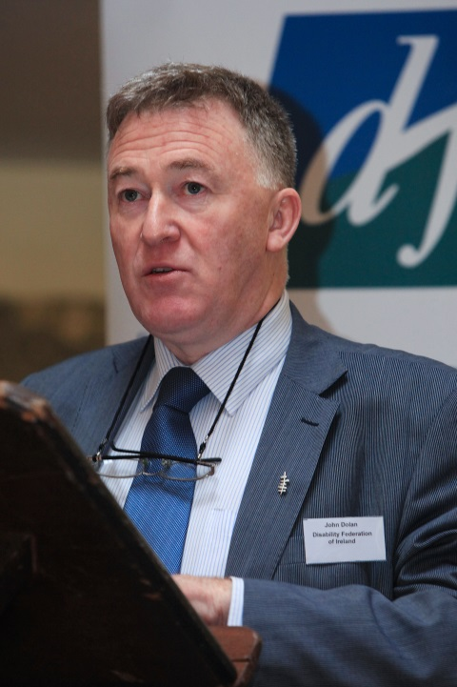
DFI Gives a Cautious Welcome to the Suspension of the Medical Card Review
The Disability Federation of Ireland (DFI) has welcomed the recent announcement from Government that the review of medical cards is to be suspended with immediate effect.
On 29 May, the Junior Minister for Health, Alex White, told the Dáil that medical card reviews were to be instantly discontinued. The Cabinet Sub-Committee on Health has since instructed Health Service Executive (HSE) officials to devise plans for the restoration of medical cards to some of those who lost them during the review.
Chief Executive of DFI, John Dolan, stated, “the decision from Government to halt the review and removal of discretionary medical cards is a welcome one for people with disabilities across the country. The review process caused undue stress and anxiety for many people with disabilities and their families, and represented further undermining of the essential supports needed by these groups”.
Chief Executive of DFI, John Dolan, expressed concern for those who had medical cards removed before the suspension of the review.
Concerns remain
He continued, “however, we remain concerned for those people who are struggling as a result of having already lost their medical cards before this announcement. Details of the plans and processes to return the card remain too vague to instil confidence in their recovery among those affected. It must be remembered that the loss of the medical card comes on top of many other financial and social challenges for these families; it is unacceptable that people with disabilities are being left to fend for themselves in this way”.
Image by artur84, courtesy of freedigitalphotos.net

The Sub-Committee on Health decided to develop a framework that considers medical conditions in the awarding of a medical card, instead of solely basing eligibility on a means test. An expert panel has been established to examine the range of conditions that may be taken account of, and a new legislative policy is likely to follow this work.
DFI has frequently acknowledged the importance of taking medical conditions into consideration in determining eligibility for the medical card. John Dolan explained, “for many people with disabilities, the costs associated with their conditions – such as general medical services and appliances, therapies, and transport – compromise their capacity to meet other basic costs of living. Denying the medical card to such people generates unfair hardship and distress for them and their families”.
Monitoring
As the situation unrolls over the coming weeks and months, DFI will continue to monitor proceedings and to work with the HSE, Government and other organisations to ensure that people with disabilities are protected. It has been noted that changes and reviews to other income supports, such as the Department of Social Protection’s review of the Domiciliary Care Allowance and new application forms for Disability Allowance, is also causing worry and complications for disabled people at this time.
Mr Dolan concluded, “people should have confidence in knowing that a full suite of strong and appropriate services and supports available which enable them to live with independence and well-being in their own communities. It is unjust to leave people with disabilities and their families in a state of limbo and insecurity as the medical card review has done. While we welcome the decision to suspend this process, we would like commitment from Government that families that lost their cards will see them restored and that the future eligibility guidelines will secure the best and fairest outcomes for people with disabilities”.
Information on entitlements to medical cards and income limits is available at http://www.citizensinformationboard.ie/publications/relate/relate_2014_03.pdf. To read more about the DFI position on the medical card scheme and review, see our Mid-Term Review of the Programme for Government at http://www.disability-federation.ie/index.php?uniqueID=10792

Disability Stakeholder Group Meets Minister Lynch Over Disability Strategy
Minister for Disability, Kathleen Lynch, attended a special meeting with the Disability Stakeholder Group (DSG) on 15 April, following a request from the group, in relation to monitoring the fulfilment of the National Disability Strategy Implementation Plan (NDSIP).
The DSG wants Government departments to work together to meet the goals of the NDSIP. Image by stockimages, courtesy of freedigitalphotos.net

Established in 2006, the DSG consists of several disability umbrella organisations, including the Disability Federation of Ireland (DFI), as well as representatives from the National Service Users Executive and a number of people with disabilities nominated by Minister Lynch. The DSG works in partnership with government on strengthening the systems and structures which underpin the implementation of the National Disability S trategy (NDS).
Minister Lynch acknowledged that serious issues around the implementation failures concerning the NDS is deeply worrying, and indicates the critical risk that exists in this area. The Minister also recognized that these issues were raised through correspondence from the DSG, rather than through any intelligence from her department. The DSG expressed disappointment that it has not been possible for the group to gain an impression of whether the implementation process is working as intended, since the publication of the NDSIP in July 2013.
The group outlined a number of issues it considers to be central in determining the progress of the NDSIP. It advised that the plan’s Key Performance Indicators (KPIs) should be revisited to set out meaningful milestones; a large portion of the actions are currently listed as “ongoing”, and therefore do not assist in identifying priorities or evaluating progress.
Image by Stuart Miles, courtesy of freedigitalphotos.net

Departmental Consultative Committees were understood to be key in the monitoring mechanism of the NDSIP; however, the DSG is concerned that only five Government departments appear to be planning such a committee. A commitment to mainstreaming is also seen to be lacking by the group: while it was intended that all relevant departments would establish a consultative mechanism in relation to the NDSIP, some have failed to do so or, where appropriate, to join another department’s committee.
Equally, it considers that the relevant departments should produce revised sectoral plans reflecting the committed actions of the NDSIP, including plans for cross-departmental coordination in line with the Disability Act 2005. Such arrangements would allow for evaluation on progress in critical areas such as children’s services, education and access to the justice system, as well as for statutory reporting on pro gress to the Oireachtas and access by people with disabilities to the Ombudsman.
The DSG contends that an assessment on the progress of the NDSIP should be undertaken at its mid-point in 2014, so that consideration can be given to planning for the post-2015 implementation plan.
For more information about the NDSIP, see our May 2014 Newsletter Special at http://disability-federation.ie/index.php?uniqueID=10885

Senator Proposes ‘Right to Love’ Bill for People with Intellectual Disability
The ‘Right to Love’ Bill, which seeks to end the discrimination of people with intellectual disabilities under current sexual offences legislation, received positive feedback during a Seanad debate on 10 June.
Image by bplanet, courtesy of freedigitalphotos.net

The Bill aims to amend the 1993 Criminal Law (Sexual Offences) Act, which leaves people with intellectual disabilities open to criminal charges if they engage in sexual activity, unless they are married or can live independently.
Senator Katherine Zappone, who tabled the Bill, explained that it “was created in response to a call to action by self-advocates and disabled people’s organisations. “I’ve been deeply touched by the rightful anger of people with disabilities who say their love is criminalised and who want to make choices for themselves”. It was researched by Dr Eilionóir Flynn and Anna Arstein-Kerslake from the Centre for Disability Law and Policy at the National University of Ireland Galway (NUIG) and Dr Brian Hunt, in consultation with these groups.
The Bill proposes to change the current law so that people with disabilities, like the population as a whole, have the freedom to consent to sexual activity and to have relationships. It provides protection from sexual abuse, and address issues such as consent to sex and understanding what is being consented to. It is in line with the principles and obligations of the United Nations Convention on the Rights of Persons with Disabilities (UNCRPD).
Self-Advocates Support Bill
Senator Zappone launched the Bill at an event in the Merrion Hotel on the same day, at which a panel of people with intellectual disabilities discussed their experiences of relationships and love, and the importance of the Bill. She pointed out that, while nobody has yet been prosecuted under the law as it stands, it has left people with intellectual disabilities in fear of the consequences of forming relationships.
Among them, Kieran Coppinger and Charlene Kelly of the Blue Teapot Theatre Company spoke of how they believe it is “unfair” that people with intellectual disabilities are treated differently under existing laws: “we have dreams, desires and goals like everyone else”, Mr Coppinger contended. Both starred in the 2013 production of ‘Sanctuary’, a play exploring relationships between people with disabilities, and later featured in the RTE documentary, ‘Somebody to Love’, on the same theme.
Brendan O’Reilly and Orla Belton of Connect People Network also described how many people doubted they could manage a relationship due to their extra support needs but that they’ve since proved them all wrong. They feel that the change in the law would allow people with disabilities to make choices for their own lives, and to have their relationships taken seriously by others. The couple have been together for eight years, living together for a few of those, and are set to marry next July.
Favourable reception
During the Seanad debate, the Minister for Justice, Frances Fitzgerald, offered support for the Bill, stating, “I have no difficulty in incorporating a number of the concepts in Senator Zappone’s Bill into the Sexual Offences Bill currently being drafted”. Addressing the wording of the legislation, she added, “like Senator Zappone, I am concerned to avoid labelling vulnerable persons. I want to avoid provisions which make blanket assumptions about the decision-making powers of persons with intellectual or learning disabilities, or those with mental health issues or cognitive disabilities”.
To find out more, or to read the Bill, visit http://senatorkatherinezappone.ie/index.php/entry/senator-zappones-new-bill-that-aims-to-reform-the-sexual-offences-law-publi/bill/. For an Easy-To-Read summary of the Bill, go to http://senatorkatherinezappone.ie/files/CLSO_Amend_Bill_2014_Summary_Every_Day_Language.pdf

Submissions Sought for BAI Public Consultation on Updated Access Rules
The Broadcasting Authority of Ireland (BAI) is seeking responses from the public and representative groups in its consultation on proposed changes to its Access Rules.
The Access Rules, in place since 2005, govern the levels of subtitling, sign language and audio-description that Irish television broadcasters must offer to the public.
Under the planned changes, RTÉ 1 will be required to reach a subtitling target of 87-92% by 2018, compared to 82-87% in 2014. TV3 will be required to reach a subtitling target of 51-55%, compared to the current 43-47%. Subtitling targets are also set for the first time for the three RTÉ television services established in 2011: RTÉjr, RTÉ Plus 1 and RTÉ News Now.
The proposals arose following a BAI review of the 2012 update to the Access Rules, and aim to make television more accessible for people with visual or hearing impairments. Speaking at the launch of the consultation, Chairperson of the BAI, Bob Collins, explained that this review found “the predominant concern of service users relates to the quality of access service provision and, in this regard, more work remains to be done”.
The consultation remains open until Wednesday, 23rd July. Those who wish to respond can do so online at http://access.baifuture.ie/, where the consultation document is available in signed video, as well as sub-titled and audio formats. Written submissions can be sent to the BAI at 2-5 Warrington Place, Dublin 2. Alternatively, the BAI will accept submissions by text to 51000 (commencing the text with ‘BAI’) or by phone to a dedicated LoCall number at 1890 940 490.

Research Programme Launched to Support People with Intellectual Disability
A new €9 million research programme, focusing on the creation of technologies to support people with autism and intellectual disabilities, was launched last month in Dublin.
The programme will see those based in the science and healthcare professions coming together with families and carers to enhance the ways in which people with disabilities communicate and learn.
Over 40 fellowships are to be awarded to researchers working on assistive technology and behavioural science over the next five years, with involvement from all Irish universities, the Royal College of Surgeons in Ireland (RCSI), Dublin and Tralee Institutes of Technology, and a number of American universities also.
Projects will include the use of computer software to help people with autism recognise facial expressions, and “eye gaze” technology to allow people with mobility difficulties to move and track objects on computer screens with their eyes.
Co-funded by the European Union Marie Curie ASSISTID Cofund and the charity Respect, it is said to be the largest research programme of its type in Europe.
For more information, visit http://ec.europa.eu/ireland/press_office/news_of_the_day/geoghegan-quinn-speech-launch-assistid-cofund_en.htm

Self-Advocates for Intellectual Disability to Host Anti-Bullying Workshop
The National Anti-Bullying Advocacy Group (NAAG) is holding a workshop for people who work in the area of intellectual disability on Friday, 4th July in the National Institute of Intellectual Disability (NIID) in Dublin.
The workshop will highlight both the lived experiences and learned understandings of bullying from the perspective of people with an intellectual disability. Discussions will cover, among other issues, the serious problem of bullying, strategies that may help services in dealing with bullying behaviours, and the importance of developing an accessible bullying policy.
The event is being run by the NAAG, a group of self-advocates who are people with intellectual disabilities speaking out for their rights. The group believe that bullying for people with an intellectual disability is endemic in the services they use and the communities in which they live.
Highlighting the importance of the workshop, the group point to the fact that people with an intellectual disability are three times more likely to be bullied than their counterparts. Although bullying can be defined in different ways, the NAAG views it as a “felt experience”: if you feel that you are being bullied, it needs to be taken seriously.
The group is asking support structures and services to engage in real listening with their users and people with an intellectual disability. The workshop is therefore designed for those in a supportive role who have a real interest in stopping the cycle of bullying for those who have an intellectual disability. The workshop costs €50 for the day, and is set to take place at the NIID, 4th floor, 3 College Green, Dublin 2. To book your place or to raise any queries, please contact Fiona Weldon at weldonfi@tcd.ie.

European Disability Forum Urges Commitment to Web Accessibility Directive
The European Disability Forum (EDF) is calling for clear commitment from the Transport, Telecommunications and Energy Council of the European Union (EU) to ensure rapid progress on the Web Directive.
The Directive aims to promote and support digital inclusion by establishing laws and regulations for EU Member States, relating to the accessibility of public sector bodies’ websites for all users. These would reflect the obligations of the United Nations Convention on the Rights of Persons with Disabilities (UNCRPD), and would be of particular benefit to people with disabilities and elderly people.
The Directive still rests at the proposal stage, with the European standard for assessing conformity with web accessibility requirements adopted in February. At a meeting of the Transport, Telecommunications and Energy Council in Luxembourg on 6 June, it was noted that 26 member states “have developed their national web accessibility policies and standards, broadly based on similar requirements”.
The EDF is now urging increased momentum on this piece of legislation during the forthcoming Italian Presidency of the EU. A recent report by the European Parliament introduced a number of important changes to the proposal, including monitoring mechanisms and accessibility training, which the EDF contends will make a real difference to the 80 million European citizens with a disability.
The organisation stated, “Non-binding political initiatives failed to make the web accessible for persons with disabilities. That is why this directive must cover all public websites as well as public services provided online, regardless of who owns the website, either it is a public or private entity”.
It is seeking support from individuals and organisations in ensuring that the Directive is quickly progressed. Those interested can share the campaign from the EDF’s Twitter and Facebook pages, using the hashtag #webaccess to discuss the issue on social media.
For more information, visit http://www.edf-feph.org/Page_Generale.asp?DocID=13855&thebloc=33682

UCC Offers Free Assistive Technology Training to Secondary School Students
The Disability Support Service of University College Cork (UCC) is offering free training in assistive technology (AT) to secondary school students.
The AT Outreach programme promotes awareness and use of such technology, and is designed to improve the ease of access and transition to Higher Education for students who are currently under-represented at third level.
Assistive Technology is any item, piece of equipment, software, product or system that is used to maintain or improve the functional capabilities of individuals with disabilities. It aims to enhance an individual’s independence and can enable students with a disability to take full of advantage of their educational potential.
Two new calendars of training events, stretching from September 2014 to May 2015, have been launched, catering for educators, students and parents.
Further information on the AT outreach programme, training events and booking is available from the UCC Disability Support Service website at http://www.ucc.ie/en/dss/assistivetech/atoutreach/

Living with Ataxia: Managing Life Is a Full-Time Job
Ataxia is the name given to a group of neurological disorders that affect balance, coordination and speech, and includes diseases such as Multiple Sclerosis and stroke, as well as hereditary Ataxias. There are many different types (both inherited and acquired) that can impact on people in different ways and to varying degrees.

Around 250 people in Ireland have some form of Ataxia, some of which are treatable, but in most cases there is still no cure. Ataxia Ireland is funding a wide range of research projects to try to find treatments - and, ultimately, a cure - that could help people with these disorders. Kiara Lynch, who tells her story below, was diagnosed with Friedreich’s Ataxia at the age of 14, after a healthy, able-bodied childhood.
Image by fotographic1980, courtesy of freedigitalphotos.net

Kiara Lynch, aged ten, celebrating Christmas Day at her Granny’s house. Kiara was told she has Friedrich’s Ataxia when she was 14 years old.

When I fell down a flight of stairs at school for the first time, I knew my world was changing. I was fourteen years old and had had noticeable problems with my balance since I was twelve. These problems included falling off my bike for no obvious reason, twisting my ankles or knees while playing sports, and running in crooked lines, to name but a few. However, during the six months between being thirteen and turning fourteen, the difficulties with my balance became even worse. I could no longer walk across an open area unaided and, when walking down a corridor, I needed to cling to the walls for support. I knew there was something seriously wrong, but I refused to think about it and tried to rationalize these issues by giving myself excuses, like “I had a bad ear infection a few weeks ago. My system hasn’t recovered yet; that’s why I’m losing my balance”.
When I was fourteen, my parents told me that I had a degenerative neurological disorder called Friedreich’s Ataxia. They told me that my balance would continue to deteriorate and I would eventually need to use a wheelchair full-time. My coordination, hand-writing and even my ability to grip a mug or glass would also get worse, and my speech would become slower and more slurred. Nobody told me at that stage that those were only the symptoms I could expect in the next ten years.
I turned 30 earlier this year and, as well as dealing with the above deteriorations for sixteen years and using my manual wheelchair full-time since I was seventeen, other symptoms have developed along the way, such as selective hearing, posture problems, and being at high risk of developing diabetes and cardiac issues. I am not going to say that my life has been easy because it hasn’t: it has been extremely difficult at times. But what the experts say is true - you do adapt, you do learn to live your life with your disability.
It is the everyday routine things that most people take for granted that I find the most difficult: getting in and out of bed, getting dressed, going to the toilet, brushing my teeth, making a cup of tea, drinking a cup of tea, eating dinner, showering. I need help with it all and even then it takes a lot of time.
“I am very lucky and I know it”: Kiara enjoying a Hawaiian cruise in 2013
Then there are the two hours of physiotherapy exercises and stretches I have to do every day, or else I will spend all day and night in pain and discomfort as my muscles spasm and contract. There are the never ending GP, consultants, orthotic, physiotherapy and occupational therapist appointments to fill those spare hours that might otherwise be spent reading or listening to music. Just in case I am not exhausted by the end of the day, my daily fatigue will kick in, making my speech almost incoherent and making me feel so tired that breathing is an effort. Managing life with a long-term disability is like having a badly paid full-time job!
Please do not mistake any of the above for self-pity. I just want people to know what Ataxia is and what people who are living with it go through on a daily basis. I am very lucky and I know it. I have a wonderfully supportive family and friends, and I went onto college and a got a full-time job. I also got married in 2012, and we have a great life together.

If you would like more information on Ataxia or would like to make a donation to Ataxia Ireland, please visit http://www.ataxia.ie/

DFI MEMBER ORGANISATIONS | NEWSLETTER DIRECTORY
For information, please contact the member organisations directly.
Irish Kidney Association Visit http://www.ika.ie/services/support-magazine-archive
Irish Motor Neuron Disease Association Subscribe to newsletter at www.imnda.ie
Irish Wheelchair Association Visit www.iwa.ie/information/publications/spokeout-magazine
Livability Subscribe to e-mail updates at http://www.livability.org.uk/
Migraine Association of Ireland Subscribe to monthly e-zine at http://www.migraine.ie
Move 4 Parkinsons Visit http://www.move4parkinsons.com/join-move4parkinsons/
Multiple Sclerosis Society of Ireland Subscribe to e-newsletters at www.ms-society.ie
Muscular Dystrophy Ireland Subscribe at http://www.mdi.ie/newsletter-by-email.html
National Council for the Blind of Ireland Magazine at http://www.ncbi.ie/news/ncbi-news-magazine
Neurofibromatosis Association of Ireland Subscribe to newsletter at www.nfaireland.ie
Offaly Centre for Independent Living Email sarah@ocil.ie to subscribe to monthly newsletter
Neurological Alliance of Ireland Sign up to newsletter at http://www.nai.ie/
Parkinsons Association of Ireland Visit http://www.parkinsons.ie/mediacentre_publications
Post Polio Support Group Newsletters at http://www.ppsg.ie/publications_survivor.html
Rehab Group Visit http://www.rehab.ie/about/rehabnews.aspx
Roscommon Disability Support Group Email mganly@rosdisabilities.ie to request copies of newsletters
Spina Bifida Hydrocephalus Ireland ‘Ability’ magazine at http://www.sbhi.ie/ability-magazine.html
Special Olympics Ireland Subscribe at http://www.specialolympics.ie/home.aspx
Spinal Injuries Ireland ‘Spinal News’ at http://www.spinalinjuries.ie/?page_id=164
Walkinstown Association Visit http://www.walk.ie/info_newsletter
Yoobyoo (formerly Children In Hospital Ireland) Subscribe to newsletter at http://yoobyoo.ie/

ACTS (Accessible Community Transport Southside) Newsletter available at www.actsltd.ie
Acquired Brain Injury Ireland Newsletter available at www.abiireland.ie/publications.html
Arthritis Ireland Subscribe to e-zine at www.arthritisireland.ie
Aware Subscribe to e-newsletter at www.aware.ie
Bodywhys Subscribe to newsletter at www.bodywhys.ie,
Bray Lakers Visit www.braylakers.ie/Newsletter/190 for newsletters
Care Alliance Ireland Visit http://www.carealliance.ie/publications_newsletters
Carers Association Subscribe at hwww.carersireland.com/newsletters.php,
Carmichael Centre Sign up for news at http://www.carmichaelcentre.ie/news
Disabled Drivers Association Subscribe to newsletter at http://www.ddai.ie
Down Syndrome Ireland Twice-yearly magazine available to members of the organisation
Dyslexia Association of Ireland Visit http://www.dyslexia.ie/about/download-section/
Enable Ireland E-newsletter at http://www.enableireland.ie/newsletter
Epilepsy Ireland Visit http://www.epilepsy.ie/index.cfm/spKey/news.html
Féach Subscribe to newsletter at http://feach.ie/index.php/newsletter
Fighting Blindness Visit http://www.fightingblindness.ie/news/email-newsletter/
GROW Subscribe at http://grow.ie/blog/publication_titles/newsletters/
Irish Guide Dogs Association Visit http://www.guidedogs.ie/iopen24/newsletters.php
HAIL (Housing Association for Integrated Living) Download newsletters at http://www.hail.ie/publications.htm
Headway Monthly e-newsletter at http://www.headway.ie/stayintouch
Heart Children Ireland Subscribe at http://www.heartchildren.ie/sign-our-newsletter
Huntington’s Disease Association of Ireland Visit http://www.huntingtons.ie/content/hope-newsletter-0
Irish Haemophilia Society Subscribe at http://www.haemophilia.ie/newsletter.php

DFI SUPPORT OFFICERS | CONTACT DETAILS

National Office
Fumbally Court Fumbally Lane, Dublin 8
Tel: 01 454 7978 Fax: 01 494 7981
E: info@disability-federation.ie

Dublin Mid-Leinster
Anthony Carrick (Dublin Office)
Dun Laoghaire, Dublin South East, Wicklow Mobile: 086 820 6736
E: anthonycarrick@disability-federation.ie

Louise McCann (currently on leave),
Dublin South City, Dublin South West, Dublin West, Kildare, West Wicklow (Dublin Office)
Mobile: 086 918 9750
E: louisemccann@disability-federation.ie
Jacqueline Grogan (Dublin Office)
Laois, Offaly, Longford, Westmeath
Tel: 01 708 0108
Mobile: 086 388 2600
E: jacquelinegrogan@disability-federation.ie

Joan O’Connor (Dublin Office)
Support Officer: Policy and Research
Tel: 01 425 0121
E: joanoconnor@disability-federation.ie

Dermot O’Donnell (Dublin Office)
Support Officer: Support for Organisations
Tel: 01 425 0125
E: dermotodonnell@disability-federation.ie

Dublin North-East
Joan O’Donnell (Dublin Office)
Meath, Louth, Cavan, Monaghan
Mobile: 086 383 4587
E: joanodonnell@disability-federation.ie

Martin Naughton
Dublin North Central, Dublin North, Dublin West
Mobile: 086 820 7196
E: martinnaughton@disability-federation.ie

West
Michael Corbett
Galway, Mayo, Roscommon
C/O DFI, 8 Acres Grove, Newport, Co. Mayo,
Tel: 098 41919
Mobile: 086 380 4750
E: michaelcorbett@disability-federation.ie
North-West
Jennifer Van Aswegen
Sligo, Leitrim, Donegal
Disability Federation of Ireland
Model Niland, The Mall, Sligo
Co Sligo
Mobile: 086 381 1261
E: jennifervanaswegen@disability-federation.ie
Toni Gleeson
Limerick, North Tipperary, East Limerick, Clare
DFI, The Forge, Croke St., Thurles, Co Tipperary
Mobile: 086 600 4526
E: tonigleeson@disability-federation.ie

South
P.J. Cleere
Carlow, Kilkenny, South Tipperary, Waterford, Wexford
DFI, Tinryland, Carlow
Tel: 059 9179431
Mobile: 086 381 1064
E: pjcleere@disability-federation.ie

Alison Ryan
Cork, Kerry.
101 North Main Street, Cork.
Tel: 021 427 1752
Mobile: 086 381 6323
E: a.ryan@disability-federation.ie

Representing the interests and expectations of people with disabilities to be fully included.
Comprising organisations that represent and support people with disabilities.

The Disability Federation of Ireland (DFI) represents the interests and the expectations of people with disabilities to be fully included in Irish society. It comprises organisations that represent and support people with disabilities and disabling conditions.
The vision of DFI is that Irish society is fully inclusive of people with disabilities and disabling conditions so that they can exercise their full civil, economic, social and human rights and that they are enabled to reach their full potential in life. DFI’s mission is to act as an advocate for the full and equal inclusion of people with disabilities and disabling conditions in all aspects of their lives.
There are over 120 organisations within membership or as associates of DFI. DFI also works with a growing number of organisations and groups around the country that have a significant disability interest, mainly from the statutory and voluntary sectors. DFI provides:
- Information
- Training and Support
- Networking
- Advocacy and Representation
- Research and Policy Development / Implementation
- Organisation and Management Development
DFI works on the basis that disability is a societal issue and so works with Government, and across the social and economic strands and interests of society.
Disability Federation of Ireland, Fumbally Court, Fumbally Lane, Dublin 8
Tel: 01-4547978, Fax: 01-4547981
Email: info@disability-federation.ie Web: www.disability-federation.ie

The Disability Federation of Ireland is a company limited by guarantee not having share capital, registered in Dublin. Registered No. 140948, CHY No 6177.
Published June 2014.

